Pearls AQI Predictor
A Serverless End-to-End Machine Learning System for 3-Day Air Quality Forecasting in Karachi
Data Science Internship Project — Ten Pearls
Prepared by: Tahreem Malik (Reem)

1. Project Overview
Pearls AQI Predictor is a 100% serverless machine learning system that forecasts the Air Quality Index (AQI) for Karachi three days in advance. The system is built around the Feature/Training/Inference (FTI) pipeline architecture: independent, automated pipelines communicate through a shared Feature Store and Model Registry rather than through one monolithic script.
The completed system includes automated data collection, a historical backfill of real Karachi air-quality data, engineered time and rolling-window features, a trained forecasting model benchmarked against a naive baseline, a live inference pipeline, SHAP-based model explainability, and an interactive, publicly deployed Streamlit dashboard — all running unattended via GitHub Actions.

2. Video Demonstration
[Insert video demonstration link here]

3. Live Links
Live dashboard: https://eixzyufmehiobse65uavs6.streamlit.app/
GitHub repository: https://github.com/Tahreem-M/pearls-aqi-predictor-

4. Architecture
The project follows the FTI (Feature, Training, Inference) architecture, a standard pattern for production ML systems:
- Feature Pipeline — fetches live weather and pollution data, computes the real EPA Air Quality Index and engineered features, and writes them to the Hopsworks Feature Store.
- Training Pipeline — pulls historical features from the Feature Store, engineers cyclical time and rolling-average features, trains and evaluates models, and pushes the best model to the Model Registry.
- Inference Pipeline — pulls enough recent feature history to compute rolling features correctly, loads the latest model, and produces a 3-day-ahead AQI forecast on demand.
Both the Feature and Training pipelines are fully automated through GitHub Actions, requiring no manual intervention.

5. Technology Stack
- Python — core language for all pipelines
- OpenWeather API — real-time weather and pollution data, and pollution history for backfill
- Open-Meteo API — free historical weather data (no API key required), used to backfill weather features beyond OpenWeather's free-tier limits
- Hopsworks — Feature Store and Model Registry (serverless, free tier)
- Scikit-learn — Ridge Regression and Random Forest models
- GitHub Actions — CI/CD automation for both pipelines
- Streamlit + Plotly — interactive, publicly deployed dashboard with gauge charts and trend visualisation
- SHAP — model explainability
- Git / GitHub — version control

6. Data Sources and Design Decisions

6.1 Computing a Real AQI
OpenWeather's own 'air quality index' field uses a simplified 1–5 scale, not the standard 0–500 EPA index used by official monitoring dashboards. This system instead computes the true EPA AQI directly from raw PM2.5 and PM10 concentrations using the official EPA breakpoint formula, taking the higher (worse) of the two pollutant sub-indices as the overall AQI — matching how real air-quality authorities report it.

6.2 Historical Backfill Strategy
OpenWeather's historical weather endpoint requires a paid subscription tier, a common blocker for a time-boxed student project. To avoid this, historical weather data (temperature, humidity, pressure, wind speed) is sourced from Open-Meteo's free historical weather API, which requires no API key. Historical pollution data uses OpenWeather's free pollution-history endpoint. This is a deliberate design choice — using the best available free source for each data type — rather than a limitation.

6.3 Feature Engineering
- Cyclical time encoding — hour, day_of_week, and month are each encoded as sin/cos pairs instead of raw integers, so December and January are correctly treated as seasonally adjacent rather than maximally different.
- Rolling averages — 24-hour and 72-hour trailing average AQI, plus 24-hour trailing average PM2.5 and PM10, giving the model short-term memory beyond a single point-in-time reading.
- AQI change rate relative to the previous reading.

7. Model Training and Evaluation
The target variable is AQI 72 hours (3 days) ahead. Because the feature pipeline's collection frequency changed during this project (from hourly to every 4 hours, to manage a cloud compute budget constraint — see Section 10), the target is matched by actual elapsed time using pandas' merge_asof rather than a fixed row-count shift, so it remains correct regardless of collection frequency. The dataset was split chronologically — training on the earlier 80% and testing on the most recent 20% — since a random split would leak future information into training, which is invalid for time-series forecasting.
Ridge Regression is wrapped in a StandardScaler pipeline, since it is sensitive to feature scale (e.g. day_of_week: 0–6 vs pm10: 0–100+); Random Forest is scale-invariant and does not require this.
Two models were trained and compared against a naive persistence baseline (predicting that AQI in 3 days equals the current AQI):
Model | RMSE | MAE | R²
Persistence (baseline) | 45.44 | 13.83 | -2.899
Ridge Regression | 28.88 | 15.77 | -0.575
Random Forest | 31.44 | 14.90 | -0.866

Ridge Regression is the deployed model (lowest RMSE), currently live in the Model Registry and used by the dashboard.

7.1 A Note on Category Accuracy
A categorical accuracy metric (percentage of predictions landing in the correct EPA AQI band) was also evaluated as a more intuitive companion to RMSE/MAE/R². It was found uninformative for the current dataset: collected AQI values have so far stayed almost entirely within the 'Moderate' band, so even the naive persistence baseline scores approximately 99% by default, making the metric non-discriminating until the dataset spans a wider range of AQI conditions. RMSE and MAE against the persistence baseline remain the primary, more meaningful evaluation metrics for this task.

7.2 Why R² Is Negative
R² compares a model against the simplest possible baseline: always predicting the historical mean. A negative R² means the model underperforms that flat-mean guess on the test window specifically. This is a known, well-documented limitation of R² on trending time series: if AQI trends consistently in one direction across the test period, as occurred during part of this project's collection window, a flat-mean baseline can appear artificially competitive purely by sitting in the middle of the range, while a model correctly tracking the trend accumulates a larger apparent error.
The persistence-baseline comparison is the more meaningful benchmark for this task. Ridge Regression reduces both RMSE and MAE by roughly a third relative to persistence, confirming the model learns genuine predictive signal from weather and pollutant patterns rather than simply assuming tomorrow looks like today.

8. Model Explainability (SHAP)
SHAP (SHapley Additive exPlanations) was used to explain individual predictions from the deployed model, answering which features pushed a given forecast up or down and by how much. A representative explanation for a recent forecast:
Feature | SHAP Contribution | Effect
month_cos | +41.45 | Increases predicted AQI
temp | -24.79 | Decreases predicted AQI
o3 | +21.30 | Increases predicted AQI
hour_sin | +12.57 | Increases predicted AQI
pm2_5 | -9.95 | Decreases predicted AQI
co | -9.88 | Decreases predicted AQI

The dominant driver is month_cos, the cyclical encoding of month, indicating a seasonal effect on Karachi's air quality now expressed through a representation that correctly treats the calendar as circular rather than linear. Temperature and ozone are the next-strongest factors, both physically plausible drivers of short-term AQI variation. This explainability layer is also surfaced live in the dashboard as an interactive chart.

9. Automation
Both the feature and training pipelines run automatically via GitHub Actions, using repository secrets to securely store API keys — no credentials are stored in code.
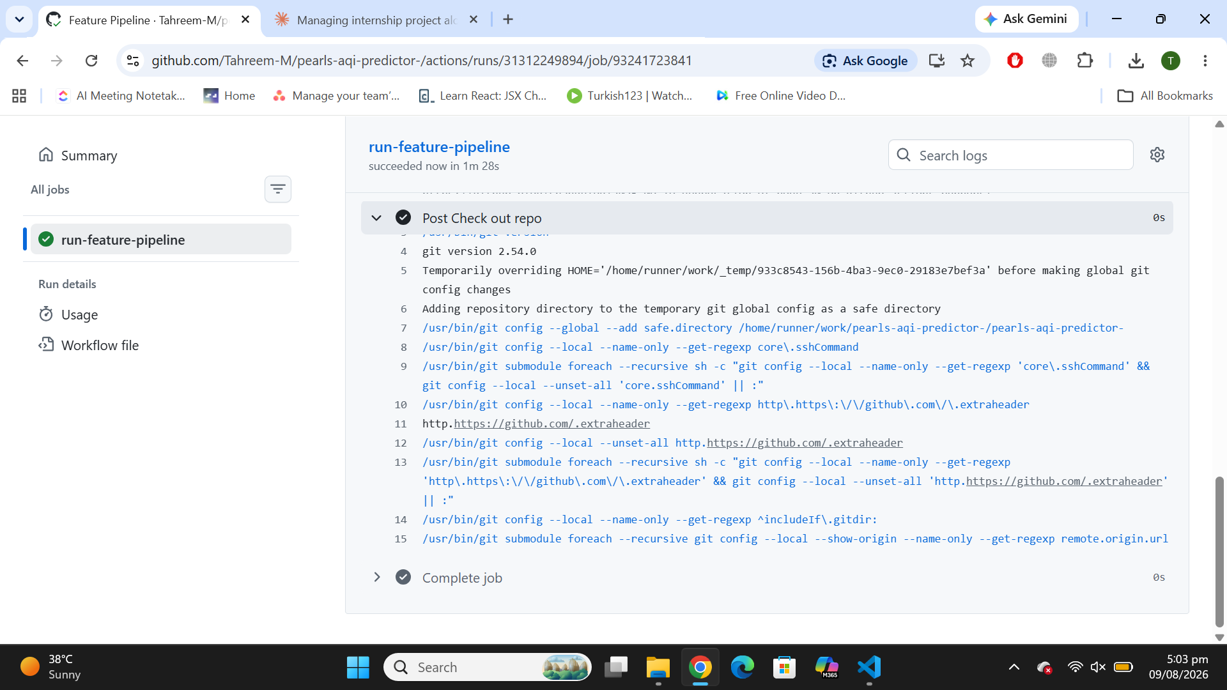
Figure 1: Feature pipeline running successfully and unattended on GitHub Actions.
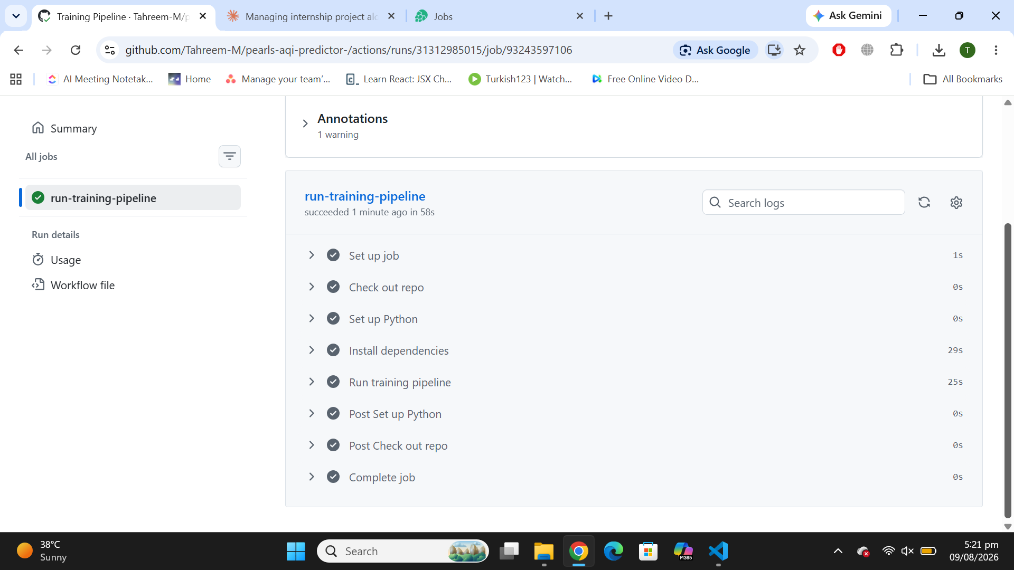
Figure 2: Training pipeline running successfully and unattended on GitHub Actions.

10. Dashboard
An interactive Streamlit dashboard, deployed publicly, presents the live forecast to end users, including gauge charts for current and predicted AQI colour-coded by EPA severity band, a hazard alert banner, a 7-day trend chart with shaded category bands, a live pollutant breakdown, and a live SHAP explanation chart.
Note: the live dashboard may take a little longer to load than expected. During the last month of development, Hopsworks' free-tier monthly compute budget (used to power the Feature Store and Model Registry) was reached, which throttled read/query performance for the remainder of that billing cycle. This has since been mitigated by reducing the automation frequency of both pipelines (see Section 12), but occasional slower load times may still be noticeable, particularly around the start of a new usage cycle.
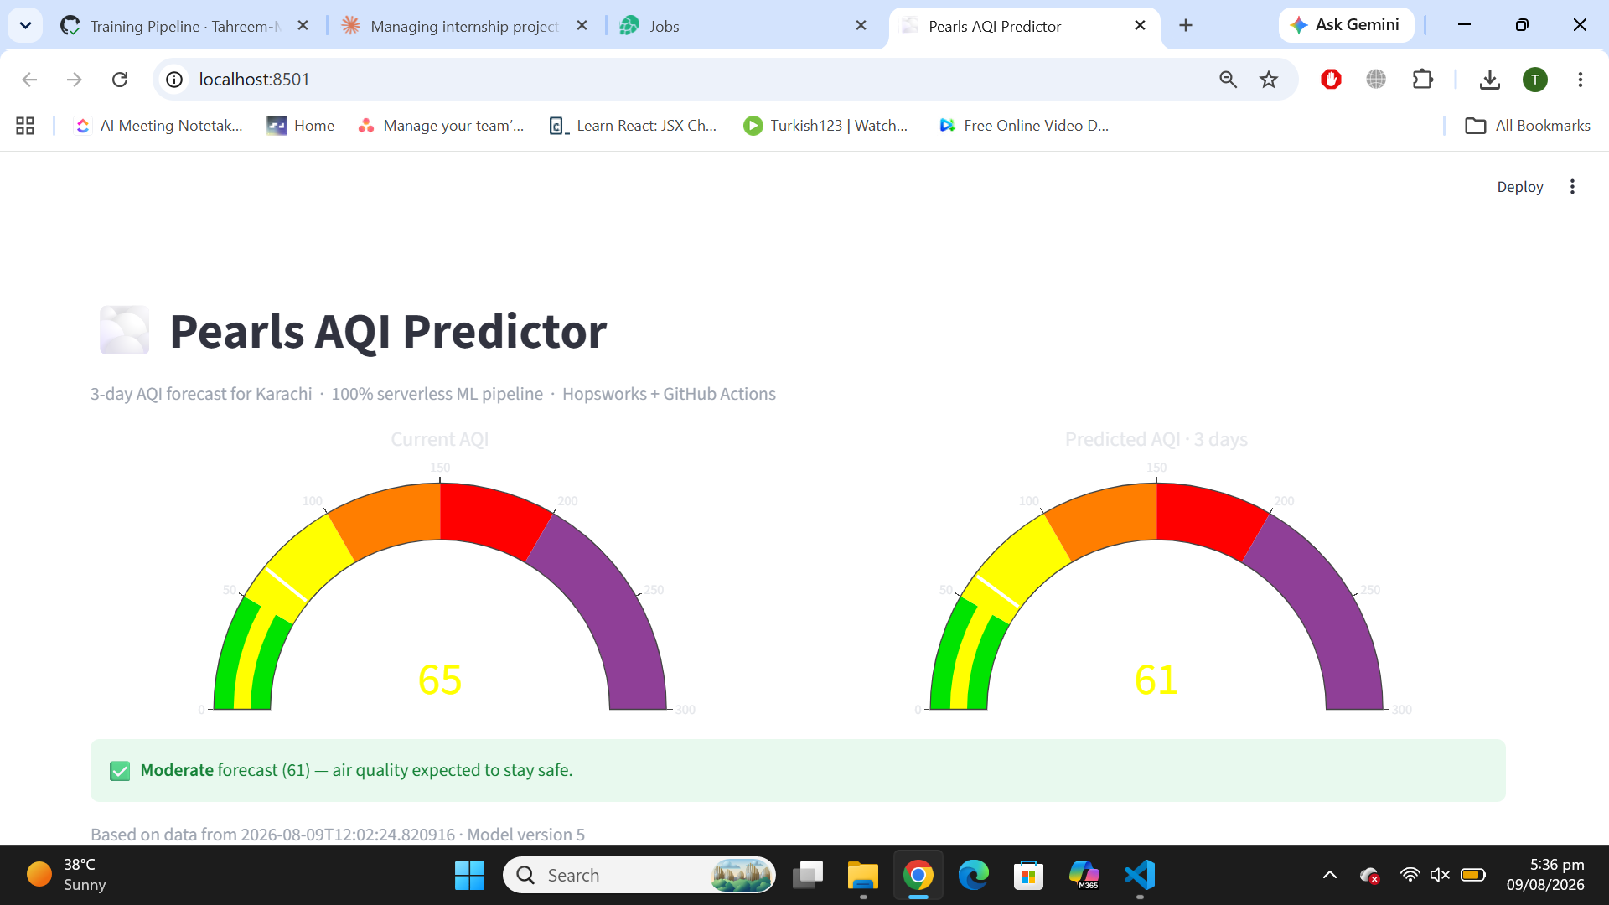
Figure 3: Current AQI and 3-day forecast gauges with hazard status banner.
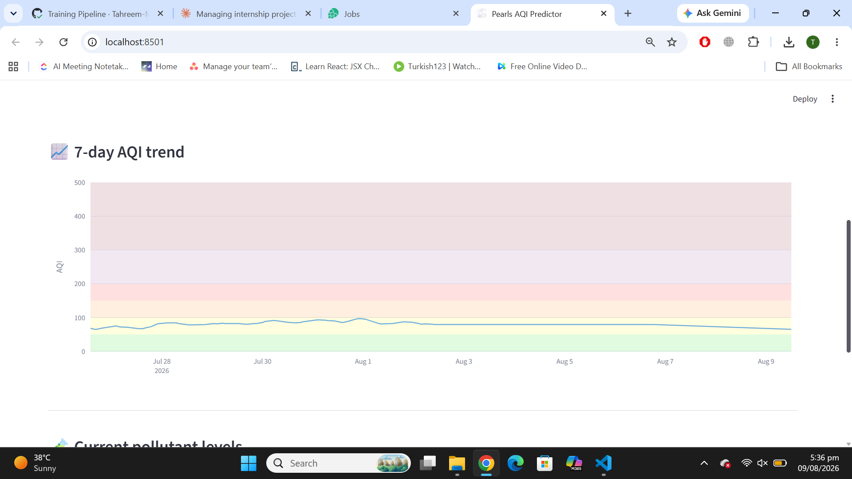
Figure 4: 7-day AQI trend with shaded EPA category bands.
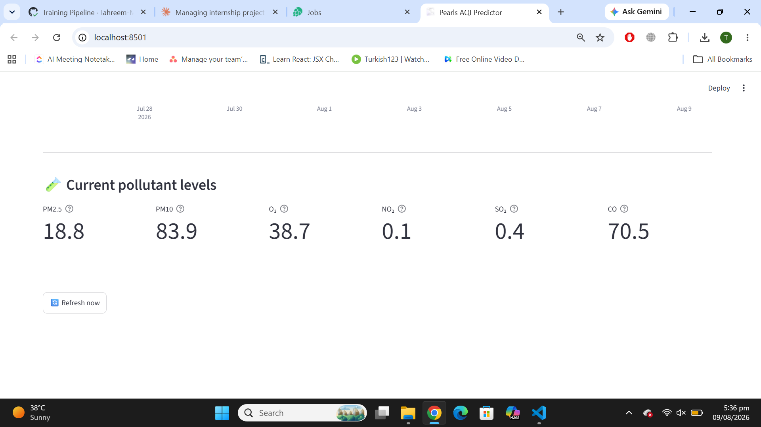
Figure 5: Live pollutant breakdown for the latest reading.

11. Problems Faced, Challenges, and Solutions
Building and deploying this project surfaced a number of real, non-trivial engineering problems. Each is documented below along with its cause and how it was resolved, since working through these was a substantial part of the project itself.

11.1 Windows SSL Certificate Errors with Hopsworks
Problem: connecting to Hopsworks' online (Kafka-based) feature store repeatedly failed on Windows with SSL certificate errors during feature insertion.
Cause: Hopsworks' online store requires downloading and materialising SSL certificates locally for its Kafka producer, and this certificate-handling process is not fully reliable on Windows.
Solution: disabled the online store for the feature group (online_enabled=False). This project only needs batch reads for training and inference, not low-latency online lookups, so the online store was unnecessary — removing it eliminated the certificate errors entirely.

11.2 Feature Store Schema Type Mismatches
Problem: feature insertion intermittently failed with errors such as 'pressure (expected type: double, derived from input: bigint) has the wrong type.'
Cause: Python's JSON parsing returns whole-number API responses (e.g. a pressure reading of exactly 1013) as integers rather than floats. Hopsworks locks a column's type based on the first value it ever receives, so any later row with a differently-typed value for the same column was rejected.
Solution: explicitly cast every numeric weather and pollutant field to float before inserting a row, in both the live feature pipeline and the historical backfill pipeline, guaranteeing a consistent type regardless of what a given API response happens to look like.

11.3 Backfill Performance
Problem: backfilling historical data by inserting one row at a time took over an hour for under 1,000 rows, triggering hundreds of repeated logins and materialization job attempts.
Cause: each individual row insert opened a new Hopsworks session and attempted to trigger a new materialization job, colliding with the previous job still in progress.
Solution: restructured the backfill pipeline to build the full historical dataset in memory and insert it as a single batch — one login, one materialization job — reducing backfill time from over an hour to under a minute.

11.4 Cross-Version Model Comparison in the Registry
Problem: the inference pipeline occasionally loaded an old model version that crashed at prediction time with a feature-mismatch error.
Cause: the model-selection logic originally picked the registry's 'best' model by comparing RMSE across all historical versions — including versions trained on an earlier, smaller feature set. A numerically lower RMSE from an incompatible older version was being selected over the current, correctly-featured model.
Solution: changed the selection logic to always load the highest model version number, since RMSE is only a fair comparison between models trained on the same feature set.

11.5 Missing Dependency in the Automated Environment
Problem: the automated GitHub Actions feature pipeline began failing with 'ModuleNotFoundError: Confluent Kafka package not found,' despite working correctly when run locally.
Cause: the local development environment had confluent-kafka installed as an incidental side-effect of an earlier package installation, masking the fact that it was never declared in requirements.txt. GitHub Actions builds a completely fresh environment on every run, so the missing dependency only surfaced there.
Solution: added confluent-kafka explicitly to requirements.txt, ensuring the local and automated environments stay in sync going forward.

11.6 Python Version Incompatibility on Deployment
Problem: both a local Windows Python installation and Streamlit Community Cloud's default Python version broke the hopsworks package with 'ModuleNotFoundError: No module named imp.'
Cause: hopsworks' dependencies rely on Python's imp module, which was removed in Python 3.12. Both the local machine and Streamlit Cloud had defaulted to newer, incompatible Python versions.
Solution: standardised on Python 3.11 everywhere — recreating the local virtual environment with Python 3.11 specifically, and adding a runtime.txt file (containing '3.11') to the repository so Streamlit Cloud provisions the correct version automatically on deployment.

11.7 Hopsworks Free-Tier Compute Budget
Problem: partway through the last month of development, the live dashboard began failing to load data, showing 'Could not read data using Hopsworks Query Service.'
Cause: running the feature pipeline hourly, plus daily model retraining, plus every dashboard page load querying Hopsworks, collectively exceeded Hopsworks' $10/month free compute allowance. Once the budget is exhausted, Hopsworks throttles and eventually freezes compute until the next monthly cycle.
Solution: reduced the feature pipeline's automation frequency from hourly to every 4 hours, reduced the training pipeline from daily to every 3 days, and increased the dashboard's internal cache duration from 5 minutes to 30 minutes — collectively cutting compute usage to roughly a quarter of the original rate. This is also why the live dashboard may occasionally take longer to load, as noted in Section 10.

11.8 Row-Count-Based Feature Alignment Silently Breaking
Problem: after reducing the feature pipeline's frequency (Section 11.7), the model's 3-day-ahead target and rolling-average features were at risk of silently becoming incorrect.
Cause: these were originally computed by shifting a fixed number of rows (e.g. 72 rows back), which implicitly assumed exactly one row per hour. Once the collection frequency changed to every 4 hours, '72 rows' no longer meant '72 hours.'
Solution: rewrote both the target-building logic and the rolling-average features to align by actual elapsed time (using pandas.merge_asof for the target, and time-based .rolling('24h')/.rolling('72h') windows for the rolling features) rather than row count, so correctness no longer depends on a fixed collection interval.

11.9 Misconfigured .gitignore
Problem: for a period, most of the project's real source files (including training_pipeline.py, hopsworks_client.py, and requirements.txt) were never appearing in GitHub, despite git commands reporting success.
Cause: the .gitignore file — auto-generated when the virtual environment was created — contained a stray wildcard (*) as its very first line, which silently caused Git to ignore the entire project directory.
Solution: identified the issue using git status --ignored, which explicitly lists ignored files, and rewrote .gitignore to only exclude the intended items (venv/, data/, models/, __pycache__/, .env).

11.10 Git Merge Conflicts from Mixed Local and GitHub-Web Edits
Problem: pushing local commits was repeatedly rejected with 'failed to push some refs... remote contains work that you do not have locally,' after editing files both locally and directly on GitHub's website.
Cause: the local and remote branches had diverged, since commits existed on GitHub that had never been pulled down locally.
Solution: used git pull to merge the diverging histories, resolved the resulting conflict in README.md by explicitly choosing which version to keep (git checkout --ours or --theirs as appropriate), completed the merge commit, and pushed successfully.

12. Future Improvements
- Extend backfill history beyond 90 days to further stabilise and validate seasonal patterns.
- Add a TensorFlow/deep-learning model to the comparison, as outlined in the original project brief.
- Support multiple cities via the existing configurable CITIES setting.
- Evaluate with proper time-series cross-validation (TimeSeriesSplit) across multiple rolling windows for a more statistically robust performance estimate.
- Investigate ensemble/blended approaches (combining the trained model with the persistence baseline) as a path toward more consistently beating persistence on RMSE.

13. Conclusion
Pearls AQI Predictor successfully implements a complete, serverless, automated machine learning system covering the full lifecycle from raw data ingestion through to an explainable, user-facing, publicly deployed forecast. Every required component from the project brief — feature pipeline, historical backfill, training pipeline, automated CI/CD, web dashboard, model explainability, and honest multi-model comparison — has been implemented, tested, and verified running in production, and the real engineering obstacles encountered along the way have been documented transparently above.

